Comparison of LDA, PCA and Naïve Bayes classifiers for the Iris dataset

The data is approximately uniformly spread between the 3 classes.

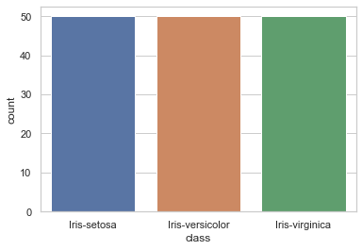

Lets start with LDA. Lets look at the confusion matrix.

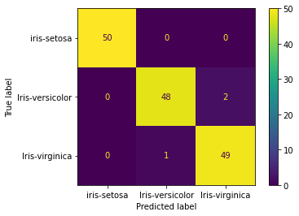

It turns out that using QDA and LDA is actually the same in this case. Let’s see if naïve bayes is any different.

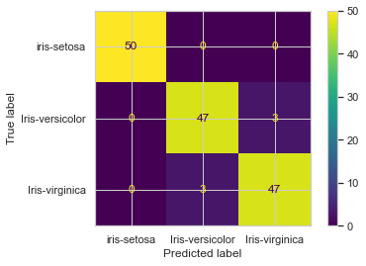

Naïve bayes performs worse than the LDA classifiers!!

A very simple explanation is that LDA and QDA allow for correlation between the 4 variables. But NB does not.

But this was done without a test train split allowing for overfitting. No tuning of hyperparameters.

Can PCA give us more insights?

Note that we haven’t split the data into test and train. Lets go ahead and do that and see if that makes a difference.